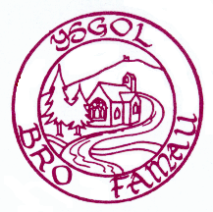

Ysgol Bro Famau Ysgol Bro Famau
Llanarmon-yn-Ial Unit Llanferres Unit
Eryrys Road Ty’n Llan
Llanarmon-yn-Ial Llanferres
CH7 5TB CH7 5SP
Tel. (01824) 780722 Ffon. (01352) 810242

Mrs. Elizabeth A. Knight M.A., N.P.Q.H.
Headteacher/Pennaeth
Email: bro.famau@denbighshire.gov.uk
Website: www.ysgolbrofamau.co.uk

Key Stage 2
Wednesday November 6th 2019
Divali Dance Workshop

November 5th 2019

Dear Parents/Carers

All pupils will spend the day at Llanferres Unit on Wednesday November 6th for our West End in Schools Divali Workshop. Where possible, please could children be dropped off at Llanferres in the morning. There will be Breakfast Club at Llanarmon and any remaining children will be transported by Baines Buses.

At the end of the school day all children should picked up from Llanferres. Bus children will be transported as normal

Yours Sincerely

Mrs. E. Knight

